Maven Project with Ansible Deployment
(MavenAnsibleWebApp1)

Procedure
Step 1: Create a Maven Project
mvn archetype:generate -DgroupId=com.example -DartifactId=MavenAnsibleWebApp1 \
-DarchetypeArtifactId=maven-archetype-webapp -DinterativeMode=false

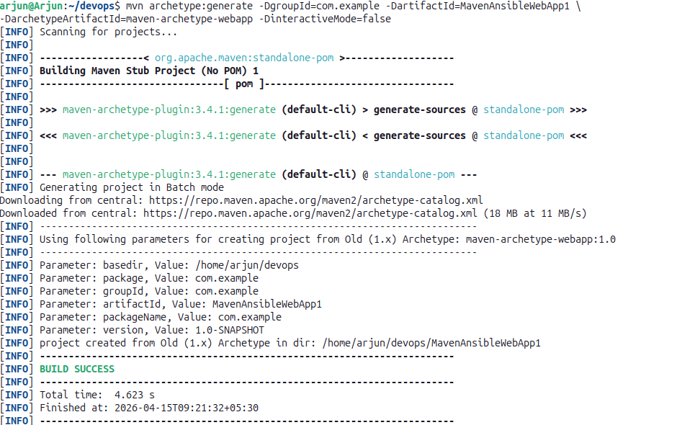

Step 2: Navigate to the Project Directory
cd MavenAnsibleWebApp1
tree
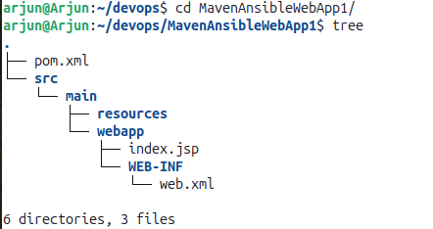
Step 3: Edit pom.xml
gedit pom.xml

pom.xml
<project
xmlns="http://maven.apache.org/POM/4.0.0" xmlns:xsi="http://www.w3.org/2001/XMLSchema-instance"
xsi:schemaLocation="http://maven.apache.org/POM/4.0.0
http://maven.apache.org/maven-v4_0_0.xsd">
<modelVersion>4.0.0</modelVersion>
<groupId>com.example</groupId>
<artifactId>MavenAnsibleWebApp1</artifactId>
<packaging>war</packaging>
<version>1.0-SNAPSHOT</version>
<name>MavenAnsibleWebApp1</name>
<url>http://maven.apache.org</url>
<dependencies>
<dependency>
<groupId>junit</groupId>
<artifactId>junit</artifactId>
<version>3.8.1</version>
<scope>test</scope>
</dependency>
<!-- Servlet API for Java EE -->
<dependency>
<groupId>javax.servlet</groupId>
<artifactId>javax.servlet-api</artifactId>
<version>4.0.1</version>
<scope>provided</scope>
</dependency>
</dependencies>
<build>
<plugins>
<plugin>
<groupId>org.apache.maven.plugins</groupId>
<artifactId>maven-war-plugin</artifactId>
<version>3.4.0</version>
<!-- Update to latest stable version -->
</plugin>
</plugins>
<finalName>MavenAnsibleWebApp1</finalName>
<!-- create a web page with the name MavenAnsibleWebApp, if we want some other name we can change it -->
</build>
</project>

Step 4: Create the Jenkinsfile (no extension)
gedit Jenkinsfile

Note: The environment block (LANG and LC_ALL) should only be added if you get an error saying UTF-8 is required but showing ISO encoding.
Jenkinsfile
pipeline {
agent any // Use any available agent

environment {
LANG = 'en_US.UTF-8'
LC_ALL = 'en_US.UTF-8'
} // this has to be added only if you get an error saying UTF required is 8 but showing in ISO00009
tools {
maven 'Maven' // Ensure this matches the name configured in Jenkins
}
stages {
stage('Checkout') {
steps {
git branch: 'master', url: 'https://github.com/likithg02/MavenAnsibleWebApp1.git'
}
}
stage('Build') {
steps {
sh 'mvn clean package' // Run Maven build
}
}
stage('Archive') {
steps {
archiveArtifacts artifacts: 'target/*.war', fingerprint: true
}
}
stage('Deploy') {
steps {
sh 'mvn clean package'
sh 'ansible-playbook ansible/playbook.yml -i ansible/hosts.ini'
}
}
}
}

Step 5: Create the ansible Directory and Configuration Files
mkdir ansible
cd ansible

hosts.ini
gedit hosts.ini

[web]
localhost ansible_connection=local ansible_python_interpreter=/usr/bin/python3

playbook.yml
gedit playbook.yml

Note: In the src field, MavenAnsibleWebApp1 refers to the name of the Jenkins pipeline. After target/, the filename is the name of the WAR file generated after compiling src/main/webapp.

- name: Deploy to Tomcat
hosts: web
become: yes
tasks:
- name: Copy WAR file to Tomcat
copy:
src: "/var/snap/jenkins/5013/workspace/MavenAnsibleWebApp1/target/MavenAnsibleWebApp1.war"
dest: "/opt/tomcat/webapps/MavenAnsibleWebApp1.war"
remote_src: no
- name: Stop Tomcat
shell: /opt/tomcat/bin/shutdown.sh || true
- name: Wait for Tomcat to stop
pause:
seconds: 5
- name: Start Tomcat
shell: /opt/tomcat/bin/startup.sh
Step 6: Check the index.jsp file

cd src/main/webapp
gedit index.jsp
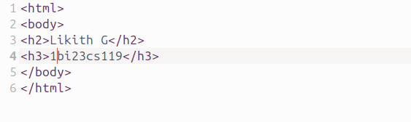
Step 7: Run the Jenkins Pipeline
Open a browser and navigate to:
localhost:8080
Create a new Pipeline job in Jenkins, configure it to use the Jenkinsfile from the repository, and run the pipeline. Jenkins will execute the Checkout, Build, Archive, and Deploy stages automatically.
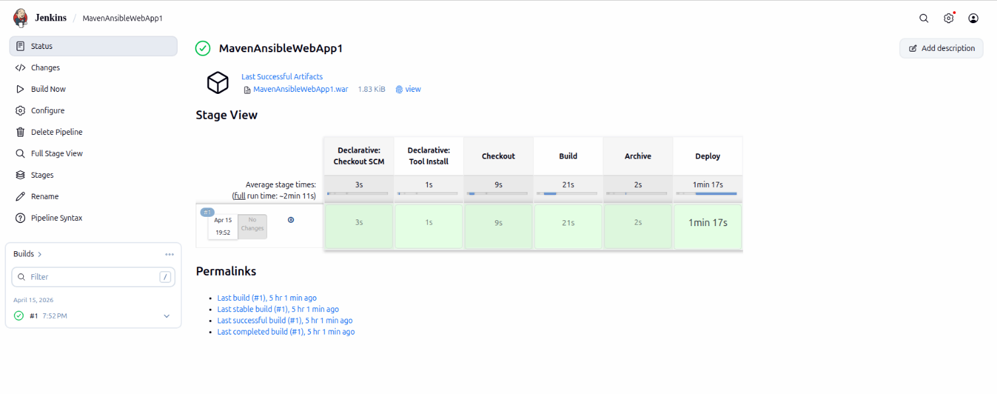

Step 7: Verify Deployment on Tomcat Server
Open a browser and navigate to the Tomcat server:
localhost:9090

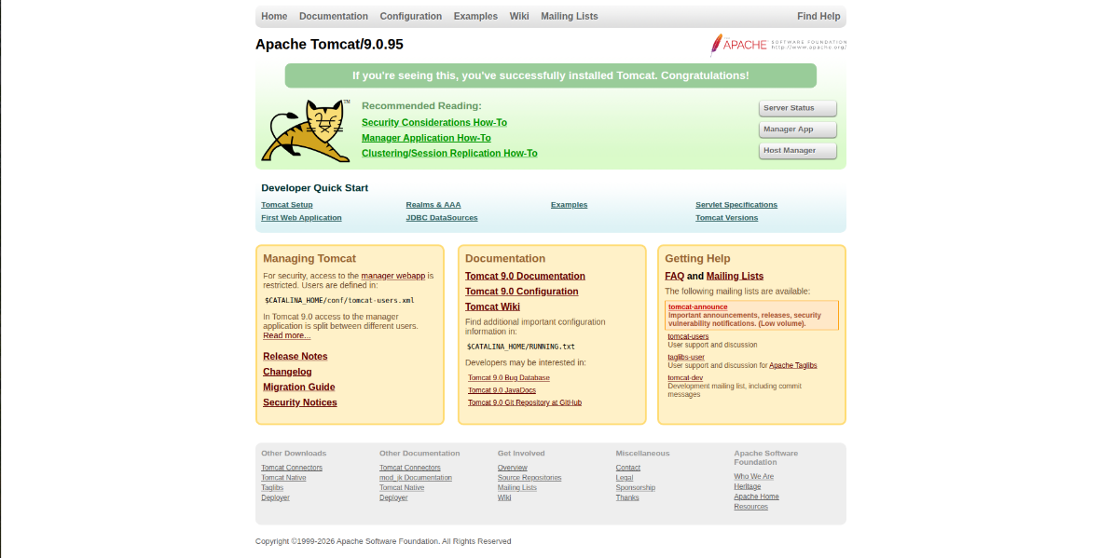

Go to Manager App. Under the list of deployed applications, click on MavenAnsibleWebApp1.
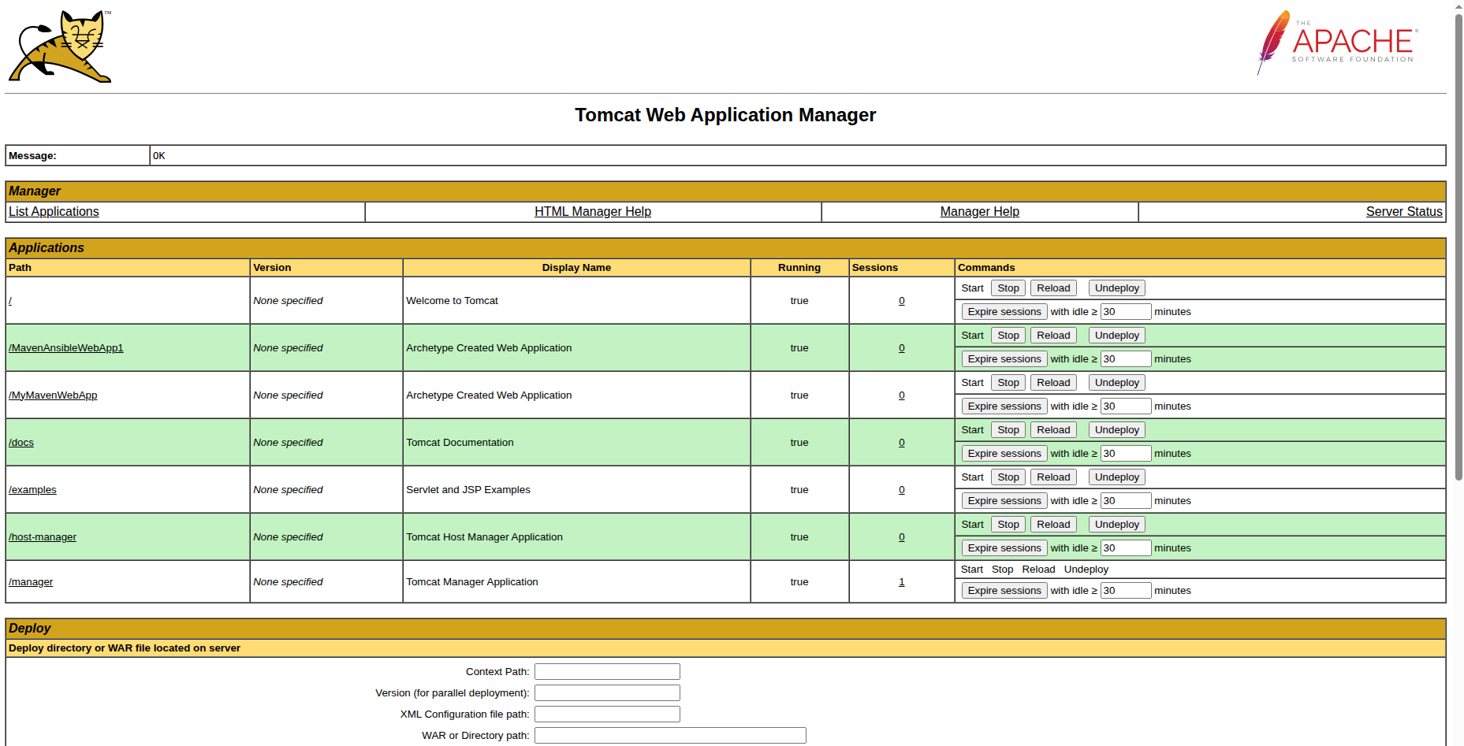

This will open the deployed web application and render the index.jsp page.



